- Three Bears in a Boat by David Soman

- Not Norman: A Goldfish Story by Kelly Bennett

- You Are (Not) Small by Anna Kang

- The Day the Crayons Quit by Drew Daywalt

- Have You Seen My Dragon? by Steve Light

- The Adventures of Beekle: The Unimaginary Friend by Dan Santat

- The Most Magnificent Thing by Ashley Spires

- Waiting Is Not Easy! By Mo Willems

- Velma Gratch and the Way Cool Butterfly by Alan Madison

- Deep in the Swamp by Donna M. Bateman

- Dragons Love Tacos by Adam Rubin

- Gaston by Kelly DiPucchio

- Froodle by Antoinette Portis

Southbridge Public Schools

2018 Summer Reading List
for
students entering Grade 1
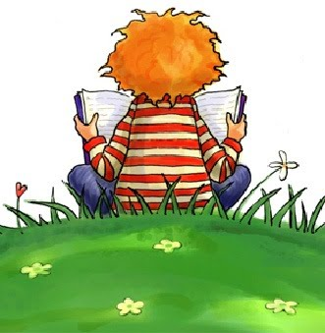

Go on a great summer adventure…..

Read a Book!
Please use this list only as a guide. These books have been chosen for their quality, their appeal to children, and their availability at Jacob Edwards Library. You are encouraged to read other titles by these authors if a particular title is not available. The librarian can assist you in selecting a different title on the same topic, by the same author, or in the same genre. Jacob Edwards Library has its own summer reading program so be sure to check it out.

- What Time Is It, Mr. Crocodile? by Judy Sierra

- One Cool Friend by Toni Buzzeo

- One is a Snail, Ten is a Crab by April Pulley-Sayre

- Little Dog Lost: The True Story of a Brave Dog Named Baltic by Monica Carnesi

- Sam and Dave Dig a Hole by Mac Barnett

Books in a Series:
- Skippy Jon Jones Series by Judy Schachner

- Pete the Cat Series by James Dean

- Pig Kahuna Series by Jennifer Sattler

- Freckleface Strawberry Series by Julianne Moore

- Nate the Great Series by Warjorie W. Sharmat

- Pinky and Rex Books by James Howe

- The Boxcar Children Series by Gertrude Chandler Warner

- Henry and Mudge Series by Cynthia Rylant

- The Very Hungry Caterpillar by Eric Carl
- The Grouchy Ladybug by Eric Carl
- Does a Kangaroo Have a Mother, Too? by Eric Carl

- Spoon by Amy Krouse Rosenthal
- Chopsticks by Amy Krouse Rosenthal
- Exclamation Mark by Amy Krouse Rosenthal

- Beautiful Oops! by Barney Saltzberg
- A Little Bit of Oomph! by Barney Saltzberg

- Rubia and the Three Osos by Susan Middleton Elya
- Little Roja Riding Hood by Susan Middleton Elya

Nonfiction Authors:
Gail Gibbons Laura Vaccaro Seeger
Judy Allen Geoff Waring
Jim Arnosky Suzanne Aker
Melvin & Gilda Berger Aliki
Joanna Cole Nicola Davies
Donald Crews Lois Ehlert
Nicola Davies Vivian French
Arthur Dorros Jean Craighead George
Dick King-Smith Linda Glaser

